ST. XAVIER’S COLLEGE

**(Affiliated to Tribhuvan University)**

**Maitighar, Kathmandu**



**INTERNSHIP REPORT**

**ON**

**“Implementing PoP3 and IMAP Protocol**

**For Desktop Email Client”**

**AT**

**GURU INFOSYS PVT. LTD**

**Under the supervision of**

**Mr. Jeetendra Manandhar**

**HoD, Department of Computer Science**

**Submitted by**

**Binaya Kharel (TU Exam Roll No. 2102/069)**

**Submitted to**

**ST. XAVIER’S COLLEGE**

**Department of Computer Science**

**Affiliated to Tribhuvan University**

**Maitighar, Kathmandu, Nepal**

**December 28, 2016**

**Implementing PoP3 and IMAP Protocol for Desktop Email Client**

**[CSC - 452]**

An Internship report submitted in partial fulfillment of the requirement for the degree of Bachelor of Science in Computer Science and Information Technology.

Submitted by

Binaya Kharel (TU Exam Roll No. 2102/069)

Submitted to

ST. XAVIER’S COLLEGE

Department of Computer Science

Affiliated to Tribhuvan University

Maitighar, Kathmandu, Nepal

December 28, 2016



# CERTIFICATE OF APPROVAL

The undersigned certify that they have read and recommended to the Department of Computer Science for acceptance, an internship report entitled “Implementing PoP3 and IMAP protocol for desktop email client” submitted by **Binaya Kharel (TU Roll No. - 2102)** in the partial fulfillment for the degree of Bachelors of Science in Computer Science and Information Technology.

…………………………

Mr. Jeetendra Manandhar

Supervisor

Department of Computer Science

…………………………

External Examiner

Tribhuvan University

…………………………

Mr. Vishnu Kumar Rana

Head of Department

Department of Computer Science

St. Xavier’s College

# ACKNOWLEDGEMENT

# ABSTRACT

With its instant global reach, email has revolutionized the way we communicate with each other. As the development in technology, email is not only limited to desktop for organizations but for everyone on the planet. Easily accessible from all the devices and ability to synchronize on all devices has made email much easier and efficient. The major downside while accessing the email is the need for an internet connection every time user wants to check email.

**“Implementing PoP3 and IMAP Protocol for Desktop Email Client”** is a project that aims to deliver a desktop email client that can simply the way user access their email. The project is expected to be extremely feasible and useful in context of Nepal. The problem of slow internet connection and load shedding are major hindrance on accessing the email anytime user need. So, the desktop email client that can save all the email on the local drive of a user can be extremely useful.

The project features on improving the existing system for email exchange and how the user access them. PoP3 and IMAP are the emerging protocols that are used by various desktop email client. Desktop email clients are versatile and more secure as they are stored on user’s local system. The user can then define their own way of accessing and backup option for their email. Flexibility of the protocol such as PoP3 which allows user to keep or delete the message from the mail server is also a huge benefit for the user. Consolidating multiple mail accounts from various provider and servers into one inbox is an important feature of PoP3 and IMAP protocol. This proposed desktop mail client will definitely aid the general users and organization in their day to day business as well as other activity.

**Keywords:** Web Email Clients, Desktop Email Clients, PoP3, IMAP

**TABLE OF CONTENTS**

CERTIFICATE OF APPROVAL 3

ACKNOWLEDGEMENT 4

ABSTRACT 5

LIST OF FIGURE 9

LIST OF TABLE 10

ABBREVIATIONS 11

CHAPTER 1: INTRODUCTION 12

1.1 Introduction to Internship 12

1.2 Background 13

1.3 Objective 13

1.3.1 Internship Objective 13

1.3.2 Objective of Project 14

1.4 Brief Introduction of Industry 14

1.5 Brief Introduction of Organization 15

1.5.1 About Organization 15

1.5.2 Organization Rationale 16

1.5.3 Organizational Hierarchy 16

1.5.4 Contact Details 16

CHAPTER 2: ANALYSIS OF ACTIVITY DONE 17

2.1 Internship Placement Details 17

2.1.1 Organization Selection 17

2.1.2 Placement 17

2.1.3 Duration 17

2.1.4 Roles and Responsibilities 18

2.2 Literature Review 18

2.2.1 A brief History of Email 19

2.2.2 PoP3 and IMAP 21

2.2.3 Security Issues in SMTP 22

2.3 Specific Problem Analysis 24

2.3.1 Understanding the Existing System 24

2.3.2 Development of Project Goals 24

2.4 Management Strategy 25

2.4.1 Time Management Strategy 25

2.4.2 Cost Management Strategy 25

2.4.3 Data Collection Strategy 25

2.5 Project Schedule 26

2.5.1 Time Schedule 26

2.5.2 Gantt chart 26

CHAPTER 3: SOLUTION DESIGN 28

3.1 Project Management Plan 28

3.1.1 System Analysis 28

3.1.2 System Design 30

3.1.3 Alternative Solution 34

3.2 Technical Requirement 34

3.2.1 Hardware Requirement 34

3.2.2 Software Requirement 35

3.2.3 Cross Platform Compatibility 35

CHAPTER 4: IMPLEMENTATION STRATIGIES 36

4.1 Testing Strategies 36

4.1.1 Unit Testing 36

4.1.2 Integration Testing 36

4.1.3 White Box Testing 37

4.1.4 Black Box Testing 37

4.1.5 User Acceptance Testing 37

4.2 Hardware Implementation 37

4.3 Software Implementation 37

CHAPTER 5: RESULT ANALYSIS 39

5.1 Result 39

5.2 Critical Analysis 41

5.3 Limitation of the System 41

5.4 Recommendation to the Organization 42

5.5 Recommendation to the Internship Program 42

CHAPTER 6: CONCLUSION 43

REFERENCES 44

# LIST OF FIGURE

Figure 1: Organizational Hierarchy of Guru Infosys 5

Figure 2: Context Diagram 20

Figure 3: Data Flow Diagram level 1 21

Figure 4: Use Case Diagram 22

Figure 5: System Sequence Diagram 23

Figure 6: SMTP settings 27

Figure 7: Sending Email 28

Figure 8: Mail Sent Successfully 28

Figure 9: Email Received By Receiver 29

# LIST OF TABLE

Table 1: Contact Detail of Guru Infosys: 17

Table 2: Internship Duration 19

# ABBREVIATIONS

|  |  |
| --- | --- |
| POP | Post Office Protocol |
| IMAP | Internet Message Access Protocol |
| API | Application Programming Interface |
| PC | Personal Computer |
| CV | Curriculum Vitae |
| SAAS | Software as a Service |
| NASDAQ | National Association of Securities Dealers Automated Quotations |
| ASCII | American Standard Code for Information Exchange |
| NYSE | New York Stock Exchange |
| IT | Information Technology |
| ARPANET | The Advance Research Project Agency Network |
| FTP | File Transfer Protocol |
| SMTP | Simple Mail Transfer Protocol |
| ESP | E-mail Service Providers |
| CTO | Chief Technical Officer |
| GPL | General Public License |
| DFD | Data Flow Diagram |
| ER | Entity Relationship |
| MUA | Mail User Agent |
| MDA | Mail Delivery Agent |

# CHAPTER 1: INTRODUCTION

## Introduction to Internship

An internship, to be succinct, is a program that allows students and recent graduates to gain practical work experience with a company or organization. Internship provides practical experience for beginners in an occupation or profession [1]. Internship programs vary widely depending on what kind of position the student holds, what type of company is hosting the internship, when and where it’s held, and what kind of compensation the student receives. The modern concept of internships essentially springs from the medieval apprenticeship, in which skilled laborers (often craftsmen) would teach a young person their trade and, in exchange, that person would agree to work for the teacher for a certain length of time [1] [2]. Internships offer students a period of practical experience in the industry relating to their field of study. This experience is valuable to students as a means of allowing them to experience how their studies are applied in the "real world", and as work experience that can be highly attractive to potential employers on a candidate's CV [3].

Internships can be done in a range of sectors, including sales, marketing, engineering, graphic design, management, I.T. and many, many more. Throughout an internship you will develop a variety of soft skills, including communication skills, personal effectiveness, presentation skills, creative problem solving and influencing skills [4].

The course Bachelor of Computer Science and Information Technology under the affiliation of Tribhuvan University includes Internship program in the final year. This program has been chiefly designed to prepare the students for the current market competition. The internship is done as a partial fulfillment of requirements of the Bachelor’s degree in Computer Science and Information Technology under Tribhuvan University. The internship is assigned six credit hours (minimum of ten weeks or 180 hours long) as a part of the course requirement.

## Background

As a part of course, the author had the opportunity to do an internship program at Guru Infosys, a software company which specializes in developing desktop as well as web based software applications. As an intern, the author was assigned with the task of developing a desktop application implementing networking protocols. As the requirement the author decided to develop a simple desktop email client implementing PoP3 and IMAP protocol. The internship included learning, developing and deploying fully functional software for sending and receiving email through a desktop mail client. The email client was developed using Java platform and Java Mail API.

An email client is an application that enables you to manage your inbox with sending, receiving and organizing messages directly from your desktop/mobile device. Specifically desktop email clients allow you to manage information exchanged via email messaging without actually having to log in and out as you typically do with web based email providers like Gmail, Yahoo, Outlook [5]

The upside of the web based email client is that there is nothing to be setup by the user, email is available on any internet connected system at any time. The downside is the client only uses the service provided and they cannot change the way they receive mail. You use what service provider provides [6].

As per the requirement, the author developed a desktop email client. Though the developed application does not include fully functional features as provided by modern desktop mail clients, it shows the basic functionality of an email client. By setting up their email address on the system, the user can send and receive mail without having to log in to their email every time.

## Objective

### Internship Objective

The main objective of internship project is to get practical experience of the theoretical academic knowledge. The objectives of internship are listed below:

* To strengthen professional skills and interpersonal relationship in professional settings
* Relating theoretical knowledge with practical aspect
* To learn and understand the organizational workflow
* To prepare students for vital career related skills such as organizational and interpersonal communication skills

### Objective of Project

The task assigned to author in internship program was to design, develop and test a Desktop Email client. From this internship project following objectives are derived:

* To design a desktop email client based on PoP3 and IMAP protocol.
* To ease the process of email management such as creation and searching of email
* To save mail on local server so they can be viewed without connecting to the internet.

## Brief Introduction of Industry

The software industry has transformed the way organizations, businesses, and even people coordinate and work. Its impact on the global economy and across various industries can be gauged by the increase in innovations, technical progress, enhanced productivity, and the workforce [7]. The software industry evolved from its beginnings in the late 1960s to become an economic giant providing United States employment alone for more than four million people. The worldwide PC software market was $88 billion in 2008, representing 30% of the total packaged-software market, which was $297 billion [8]. The software industry can be separated into four main categories: programming services, system services, open source and SaaS. The following describes the categories of business software used in the industry.

**Programming Services:** This sector has historically been the largest sector and includes names such as Microsoft Corporation (NASDAQ: MSFT), Automatic Data Processing, Inc. (NASDAQ: ADP), Oracle Corporation (NYSE: ORCL) and SDC Technologies, Inc. These companies often pioneered solutions to needs by businesses to analyze data, store and organize data, or provide programs to run machinery.

**System Services:** Although programming was the largest software sector early in computer history, system services grew rapidly through the 1960s and 1970s, and then exploded in the 1980s with the rise of personal computers (PCs) and the need for an encompassing operating system such as Microsoft’s original disk operating system (DOS) that was launched in 1981 [8] [9].

**Open Source:** Programming or software engineering has become a huge in-demand profession with the growth of the Internet, cloud systems and businesses willing to venture more willingly into open-source environments such as the Linux operating system. Open source refers to a code base that was created and is free to acquire. However, most businesses require changes to be made to the code bases to suit their needs. Another open-source code base is the Android operating system.

**Software as a service:** With the rise of cloud computing and the movement of most businesses large and small to the cloud, SaaS has become more popular than system software for businesses' specific needs. This software is kept on the creators' servers and clients access the software through the Internet, also referred to as the cloud [9] [10].

## Brief Introduction of Organization

## About Organization

Guru Infosys is a registered company established by well experienced IT professionals and certified engineers in Nepal. Guru have invested a significant time in research on client need and innovation on production features and specialties. Guru Infosys is now in market with number of software products such as Guru-Sahakari (Co-operative Management System), Guru Accounts (Accounting software based on double entry system), Auto Guru and many more.

## Organization Rationale

As one of the pioneer of software development in Nepal, Guru has passion for excellence and to win with flawless execution. Customer satisfaction is placed above all at Guru Infosys. Guru responds to any of their customers all while seeking to exceed their expectations.

Teamwork is observed at its best at Guru Infosys. The company treats one another with respect and communicates openly. It fosters collaboration and maintains individual accountability. Guru encourages “anyone can do” attitude and appreciates value of multiple perspectives and diverse expertise.

## Organizational Hierarchy

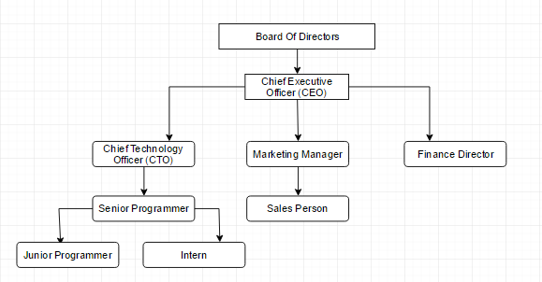

Figure 1: Organizational Hierarchy of Guru Infosys

## Contact Details

|  |  |
| --- | --- |
| Organization | Guru Infosys |
| Organization Type | Pvt. Ltd. |
| Location | Bafal-13, Kalanki, Kathmandu |
| Phone no | +1 4286977, 4278095 |
| Website | Guruinfosys.com |
| Email Address | info@guruinfosys.com |

Table 1: Contact Detail of Guru Infosys:

# CHAPTER 2: ANALYSIS OF ACTIVITY DONE

## Internship Placement Details

### Organization Selection

The first phase of the internship was the selection of organization for internship. Among the various criteria provided in internship prerequisite, application development was chosen. Various software companies were shortlisted and approached. Since internship provides the practical experience for the theoretical knowledge gained, selection of proper organization for the internship program was important. Selection of organization which is working in domain which is coherence with the final year project of the student is very important. Guru Infosys has been a pioneer in design and development of web based as well as desktop application.

### Placement

Application for internship was sent to various institutes, and after 2 weeks, the author was called by Guru Infosys for the interview. After selection, the author was placed under the supervision of Er. Milendra Tuladhar. The author was selected as an intern for software development in the organization.

### Duration

|  |  |
| --- | --- |
| Start Date | September 9, 2016 |
| End Date | December 5, 2016 |
| Total Duration | 3 Months |
| Position | Intern |
| Supervisor | Er. Milendra Tuladhar |
| Office Hour | 10 AM – 6 PM |

Table 2: Internship Duration

### Roles and Responsibilities

The internship at Guru Infosys involved various activities and task as per the requirement of both the organization and the project. The goal of the internship program was to develop a desktop email client using java programming. Extensive preliminary studies about mail clients, working of PoP3 and IMAP protocol.

Study of the existing system was carried out extensively during the research phase. Various papers on IMAP and PoP3 protocols are thoroughly studied. Requirement specification analysis was done after discussion with internship supervisor. Project planning, design and implementation was carried out as per the project requirement under the guidance of supervisor.

## Literature Review

With its instant global reach, email has revolutionized the way we communicate with each other. As the technology makes its way to more devices, such as mobile phones and tablets, its influence continues to grow. It's the pen and paper of the 21st century, but offers so much more [11]. Email has made communication instant and global. You can send a message to the other side of the world in seconds for the price of an Internet or data connection. Email systems are based on client server architecture and message is send from any clients to a central server. This central server reroute mail to its intended destination. The first “real” email was found by Ray Tomlinson of the now defunct ARPANET network, which in 1971 sent out a message which he received seconds later, on a computer placed next to the first one. The first email client program ever developed was named MSG. At the beginning, email was sent through a FTP (File Transport Protocol)-like structure. MSG was also one of the basis in creating the SMTP (Simple Mail Transfer Protocol)-type server, which is now the standard gate through all or our messages pass in order to reach their email clients. One of the first email clients that offered the user with a text interface was Elm. Email has evolved into communication tool of choice for IT, academics and professional.

Some of the limitations of earlier email client are:

* It could send only text files and even though user could send images, programs and files like Microsoft word some users was not able to use it [12].
* Other problem was lack of context support or limited context for which the users would require a dynamic way to connect related messages.
* Most of the email clients are based on single username and password. This authentication is considered to be unsafe as the hacker could easily get the password through dictionary method.
* Protection of mailboxes is other major issue. As the mail letters on servers depend on operating system and if the operating system is not properly configured hackers could easily attack the mailbox.
* Spam and phishing is considered to be other major issue which exploits the authorization of email standards thus resulting in anyone sending email to any other user.

### A brief History of Email

Email is much older than Arpanet or the Internet. It was never invented; it evolved from very simple beginnings. Early email was just a small advance on what we know these days as a file directory - it just put a message in another user's directory in a spot where they could see it when they logged in. Simple as that. Just like leaving a note on someone's desk [13]. Probably the first email system of this type was MAILBOX, used at Massachusetts Institute of Technology from 1965. Another early program to send messages on the same computer was called SNDMSG.

Some of the mainframe computers of this era might have had up to one hundred users -often they used what are called "dumb terminals" to access the mainframe from their work desks. Dumb terminals just connected to the mainframe - they had no storage or memory of their own, they did all their work on the remote mainframe computer [14].

Before internetworking began, therefore, email could only be used to send messages to various users of the same computer. Once computers began to talk to each other over networks, however, the problem became a little more complex - We needed to be able to put a message in an envelope and address it. To do this, we needed a means to indicate to whom letters should go that the electronic posties understood - just like the postal system, we needed a way to indicate an address [14] [15].

This is why Ray Tomlinson is credited with inventing email in 1972. Like many of the Internet inventors, Tomlinson worked for Bolt Beranek and Newman as an ARPANET contractor. He picked the @ symbol from the computer keyboard to denote sending messages from one computer to another. So then, for anyone using Internet standards, it was simply a matter of nominating name-of-the-user@name-of-the-computer. Despite what the World Wide Web offers, email remains the most important application of the Internet and the most widely used facility it has. Now more than 600 million people internationally use email. By 1974 there were hundreds of military users of email because ARPANET eventually encouraged it. Email became the savior of Arpanet, and caused a radical shift in Arpa's purpose [16].

The first important email standard was called SMTP, or simple message transfer protocol. SMTP was very simple and is still in use. SMTP was a fairly naïve protocol, and made no attempt to find out whether the person claiming to send a message was the person they purported to be. Forgery was (and still is) very easy in email addresses. These basic flaws in the protocol were later to be exploited by viruses and worms, and by security frauds and spammers forging identities [16].

When Internet standards for email began to mature the POP (or Post Office Protocol) servers began to appear as a standard - before that each server was a little different. POP was an important standard to allow users to develop mail systems that would work with each other.

With the World Wide Web, email started to be made available with friendly web interfaces by providers such as Yahoo and Hotmail. Usually this was without charge. Now that email was affordable, everyone wanted at least one email address, and the medium was adopted by not just millions, but hundreds of millions of people [17].

### PoP3 and IMAP

IMAP (Internet Message Access Protocol) is a standard email protocol that stores email messages on a mail server, but allows the end user to view and manipulate the messages as though they were stored locally on the end user's computing device(s). This allows users to organize messages into folders, have multiple client applications know which messages have been read, flag messages for urgency or follow-up and save draft messages on the server [18].

IMAP can be contrasted with another client/server email protocol, Post Office Protocol 3 (POP3). With POP3, mail is saved for the end user in a single mailbox on the server and moved to the end user's device when the mail client opens. While POP3 can be thought of as a "store-and-forward" service, IMAP can be thought of as a remote file server. Most implementations of IMAP support multiple logins; this allows the end user to simultaneously connect to the email server with different devices. For example, the end user could connect to the mail server with his Outlook iPhone app and his Outlook desktop client at the same time. The details for how to handle multiple connections are not specified by the protocol but are instead left to the developers of the mail client [18] [19].

Once an IMAP session is established, all communication between the client and server takes place in the form of commands sent by the client and responses returned by the server. Like POP3, commands and responses are sent as strings of ASCII text and terminated with a? CRLF? sequence, making them compatible with the way data is sent using the Telnet Protocol. However, IMAP does a few things quite differently than POP and many other TCP/IP application protocols.

The first interesting thing about IMAP commands is that most are not abbreviated into codes of three or four letters, they are spelled out in full. So, where POP3 has a STAT command, the one in IMAP is called STATUS. Commands are normally shown in upper case, as I do in this Guide, but are in fact case-insensitive. IMAP also uses an interesting system of command tagging to explicitly match client commands with certain server responses. Each time a client sends a command, it prefixes it with a tag that is unique for the particular session.

### Security Issues in SMTP

Security in Information and Communication Technology is defined as adequate protection of information against unauthorized disclosure, unauthorized modification and unauthorized withholding [20]. It has a close relationship with privacy as insecure information cannot ensure users privacy. In E-mail messaging, security can be defined as the ability of the system to provide i) privacy, ii) sender authentication, iii) message integrity, iv) non-repudiation, and v) consistency [21]. These parameters are briefly described below:

1. Privacy guarantees confidentiality of a message transmitted over open medium which otherwise can be intercepted or altered.
2. Sender authentication is the verification of the claimed identity of the sender.
3. Message integrity refers to policies that ensure security against mail forgery which includes policies to stop transmission of spam e-mails; phishing e-mails and e-mails containing viruses, etc.
4. Non-repudiation means non-denial by sender; an e-mail sender should not be able to disown an e-mail sent by him due to weak security mechanism.
5. Consistency refers to uniformity of both header and body of the message from source to the destination.

E-mail system consists of a number of hardware and software components that follow some defined standards. These standards also include standards for message addressing and formatting and a number of related protocols. Simple Mail Transport Protocol [22] is the primary and the most widely adopted protocol for e-mail delivery. It lacks security features for privacy and authentication of sending party. E-mail in plain text passes from sender to recipient through many intermediaries like routers, and mail servers. It is thus, inherently vulnerable to both physical and virtual eavesdropping as malicious attackers who gain access to these intermediaries can read e-mails. Further, E-mail Service Providers (ESPs) have capabilities to store copies of e-mail messages even when these are deleted by the users from their mailboxes [21]. It has no mechanism to authenticate the sender or other trusted fields in any way. It does not verify or validate the senders e-mail address or other header fields. As such senders can lie about their true identities [23], date and time of creation of message, return address and other details which result in security challenges of different types. It has no security feature for message integrity and as such it is possible to send spam and phishing e-mails. Spam e-mails cause several problems like network conjunction, misuse of storage space and computational resources, loss of work productivity and annoyance to users, legal issues as a result of pornographic advertisements and other objectionable material, financial losses through phishing and other related attacks like spread of viruses, worms and Trojan Horses, and Denial of Services and Directory Harvesting attacks [24].

## Specific Problem Analysis

Specific problem analysis is the in-depth analysis of the domain to better understand the problem and work towards its solution. It defines the degree of the problem and helps to recognize whether the problem is genuinely related to the subject matter. With the root cause of the problem analyzed, various counter measures such as developing an alternative can be taken.

### Understanding the Existing System

Various existing systems, both web based and desktop mail clients were studied. Various mail protocols were also studied for the better understanding of mail protocols. Various desktop mail clients such as Mailbird, Outlook by Microsoft, Mozilla Thunderbird were studied. The existing mail clients support various protocols and have multiple functions which user can chose from. These function make the software far more useful but complex as well. The email client proposed by the author is far simpler than the existing system and is easier to use.

### Development of Project Goals

After thorough study and having better understanding of the existing system, and analyzing the problem to be solved, the goals for the project were formulated. Following were the goals developed by the author:

* The interface design for the new system can be made simpler than existing system
* Support for both PoP and IMAP protocols are added
* Support for any mail services such as Gmail, Outlook etc

## Management Strategy

### Time Management Strategy

“Time Management” is the process of organizing and planning how to divide the time between specific activities [25]. Effective time management strategy can protect project from heading toward failure. Collecting the task in a to-do list is an effective way of remembering the thing to be done during the development of project. Estimating task and setting deadline for each of the task will avoid last minute problems. Similarly, setting priorities for the work to be done can also save a lot of time. Difficult task get the highest priorities and must be solved before moving to any other task.

### Cost Management Strategy

Cost management is the process of planning and controlling the budget of a business. Cost management is a form of management accounting that allows a business to predict impending expenditures to help reduce the chance of going over budget [26]. Development, Operational and Maintenance cost are the factors that are considered highly during the development of the project. The system is developed in java which is a free open source programming platform. Since the API used are also free and the system runs on local computer there is no additional server charges. Similarly, maintenance

### Data Collection Strategy

#### Interview

Interview is conducted with CTO of Guru Infosys on how the proposed system can be developed and what are the technologies that can be used. Various question were raised about the efficiency of Desktop based system over Web based client.

#### Secondary Sources

Internet was the secondary source of research for this project. The research was done on the internet to understand the system better and learn the current trends in development of desktop email clients.

## Project Schedule

### Time Schedule



### Gantt chart

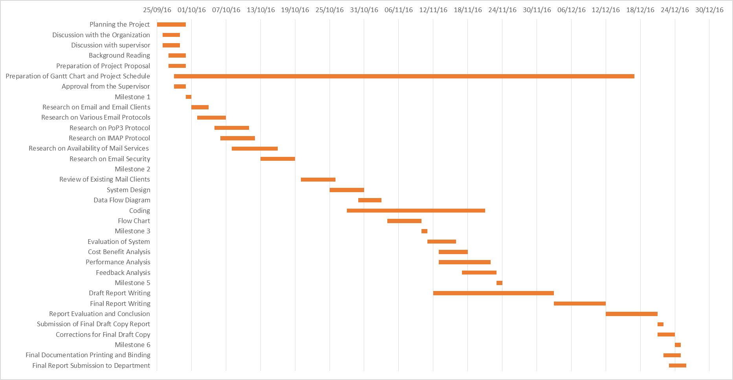

# CHAPTER 3: SOLUTION DESIGN

## Project Management Plan

Project management is the discipline of using established principles, procedures and policies to manage a project from conception through completion [27]. Project management oversees the planning, organizing and implementing of a project. A project is an undertaking with specific start and end parameters designed to produce a defined outcome [28]. The overall development of the system was carefully analyzed under the proper guidance from the supervisor.

### System Analysis

Systems analysis the process of observing systems for troubleshooting or development purposes. It is applied to information technology, where computer-based systems require defined analysis according to their makeup and design [29]. The system analysis was done to check whether it would be feasible with regard to issue with technology, economy and various other aspect that may affect the system under development.

#### Feasibility Study

The main aim of the feasibility study activity is to determine whether it would be financially and technically feasible to develop the product. The feasibility study activity involves the analysis of the problem and collection of all relevant information relating to the product such as the different data items which would be input to the system, the processing required to be carried out on these data, the output data required to be produced by the system as well as various constraints on the behavior of the system [30] [31].

##### Technical Feasibility

The technical issue of the system usually raised during the feasibility stage of the investigation includes the following:

* Does the necessary technology exist to do what is mentioned?
* Is the system upgradeable?
* Is the system reliable, accurate and consistent?

The system is technically feasible, since all of the required resource are open source and available freely. Various mail API’s can be used for the development of the system. The system provides technical guarantee of accuracy, reliability and security.

##### Economic Feasibility

Economic feasibility determines whether the required software is capable of generating financial gains for an organization. It involves the cost incurred on the software development team, estimated cost of hardware and software, cost of performing feasibility study, and so on [32]. The application is built using open source platform and therefor does not require any additional hardware and software. All the development toolkit are available free of cost.

##### Legal Feasibility

The legal feasibility analyzes and deals with various legal issues and investigates if the proposed system conflicts with legal requirements like data protection acts or social media laws [33]. The legal issue in this project are none since java is an open source platform under GNU General Public License, which guarantees end users the freedom to run, study, share and modify the software.

##### Operational Feasibility

Operational feasibility is a measure of how well a proposed system solves the problems, and takes advantage of the opportunities identified during scope definition and how it satisfies the requirements identified in the requirements analysis phase of system development [34]. The system operates with bare minimum faults and the application being developed in java, the application can be executed in any operating platform.

##### Schedule Feasibility

Schedule Feasibility is defined as the probability of a project to be completed within its scheduled time limits, by a planned due date. If a project has a high probability to be completed on-time, then its schedule feasibility is appraised as high. In many cases a project will be unsuccessful if it takes longer than it was estimated [35]. Since the project was going accordingly to time schedule so it is feasible.

### System Design

#### Context Diagram

The Context Diagram shows the system under consideration as a single high-level process and then shows the relationship that the system has with other external entities (systems, organizational groups) [36].

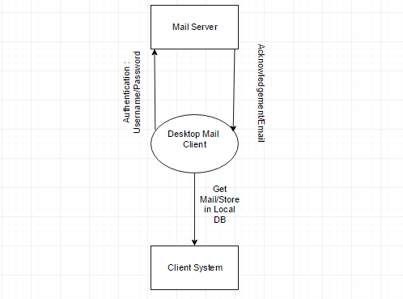

Figure 2: Context Diagram

Figure 1 shows the context diagram of the email client. The above diagram shows how client and server communicates with desktop mail clients and what input and output are given by each components. Here mail clients authenticates the user information with mail server and receives email if the information is authentic. Whereas on the client system the desktop mail client stores all the email received.

#### Data Flow Diagram (DFD)

Data flow diagram is graphical representation of flow of data in an information system. It is capable of depicting incoming data flow, outgoing data flow and stored data. The DFD does not mention anything about how data flows through the system. DFDs consist of four major components: entities, processes, data stores, and data flows [37].

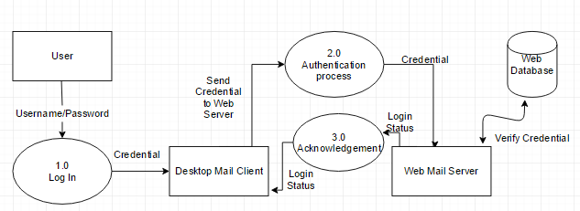

Figure 3: Data Flow Diagram level 1

Figure 2 shows the level 1 DFD for the desktop mail client. The process 1.0-3.0 include verification of user credential while logging to Desktop mail client. Each entity and the data flow between them and the process are show in above figure.

#### Use Case Diagram

Use case diagrams are usually referred to as behavior diagrams used to describe a set of actions (use cases) that some system or systems (subject) should or can perform in collaboration with one or more external users of the system (actors). Each use case should provide some observable and valuable result to the actors or other stakeholders of the system [38].

C:\Users\lambo\Downloads\UseCase.png

Figure 4: Use Case Diagram

Figure 3 shows the use case diagram for the desktop mail client. The actor show above is the direct user of the system. Since, mail client is a single user system, there is only one stakeholder i.e. user.

#### System Sequence Diagram

Sequence diagrams are used to show how objects interact in a given situation. An important characteristic of a sequence diagram is that time passes from top to bottom: the interaction starts near the top of the diagram and ends at the bottom (i.e. Lower equals later). A popular use for them is to document the dynamics in an object-oriented system. For each key collaboration, diagrams are created that show how objects interact in various representative scenarios for that collaboration [39].

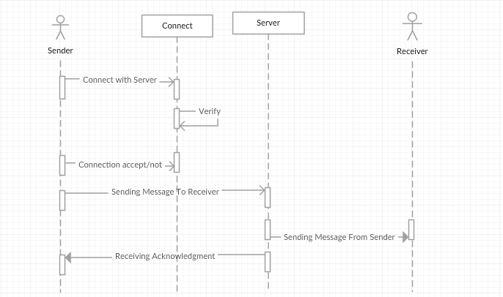

Figure 5: System Sequence Diagram

Figure 4 shows the sequence diagram of the basic operation of Email client. The actor sender and receiver and the interaction between them are shown in sequential format in the above diagram.

### Alternative Solution

The degree of the success in developing the new proposed application according to the customer’s requirement and criteria is determined by the proper selection of the best alternatives. Such chosen best alternative should be properly implemented using the most suitable methods and procedures. Since, the application is a desktop mail client, java swing technology was used. Using Java Swing application with GUI interface can be created which is easier for user interaction. However, the same application could be built in java web. A web application would have been easier to build and since technologies such as JavaScript and CSS could be used in web application, the application could have nice UI design. But the web application depends on browser to run and the application cost may increase in long run. Disabling JavaScript on browser may affect the performance of overall system and the application may no run on every browser. So, the system was developed using java swing technology.

## Technical Requirement

### Hardware Requirement

The minimum Hardware requirements are:

* Intel Pentium IV processor
* 1GB RAM
* Hard Drive 20GB
* Personal laptop/computer

### Software Requirement

* Operating System (any)
* JDK 7.0 or later
* Java Mail API

### Cross Platform Compatibility

Since the application code is written in Java, it can be hosted in any operating system. Since java is an open source cross platform compatible language all the libraries and API used in the application are supported by any operating system and devices.

# CHAPTER 4: IMPLEMENTATION STRATIGIES

## Testing Strategies

Testing is the process of evaluating a system or its component(s) with the intent to find whether it satisfies the specified requirements or not. In simple words, testing is executing a system in order to identify any gaps, errors, or missing requirements in contrary to the actual requirements [40]. Some of the testing strategies used during the development of the system are:

### Unit Testing

Unit testing is a technique using which individual modules are tested to determine if there are any issues by the developer himself. It is concerned with functional correctness of the standalone modules [41]. Various modules are tested separately during unit testing.

* Message Sending Module:

Message was sent to another email address with attachment. Message was delivered successfully.

* Setting Properties:

Username, password and SMTP port and server were set up successfully.

### Integration Testing

Integration testing is the process of bringing together all the modules to verify the combined functionality. In this project, the integration test was done to conform the interaction between Sending Module, Receiving Module and SMTP properties module. The confirmation was done by running the application in a real time scenario

### White Box Testing

This testing is based on knowledge of the internal logic of an application’s code. Also known as Glass box Testing. Internal software and code working should be known for this type of testing [42]. During this testing phase no errors were encountered.

### Black Box Testing

Black box testing is a testing technique that ignores the internal mechanism of the system and focuses on the output generated against any input and execution of the system. It is also called functional testing. In this project, the black box testing is performed with many test cases. The test data are prepared and the outputs are seen. To see how errors are handled, the wrong inputs were also given to the system. The system handled the wrong inputs safely.

### User Acceptance Testing

Normally this type of testing is done to verify if system meets the customer specified requirements. User or customer do this testing to determine whether to accept application [43]. The system was provided to number of colleagues for use. The feedback was used to improve the system performance

## Hardware Implementation

The system was implemented on the system with following specifications:

* 8 GB RAM
* Intel I5 dual Core Processor

## Software Implementation

The system was implemented on:

* Windows 10 Home
* JDK 8.0.1

# CHAPTER 5: RESULT ANALYSIS

## Result

The system is supposed to work as a desktop email client which could help the user to get their email information. The user can view the incoming email as well as send their own email using this application.

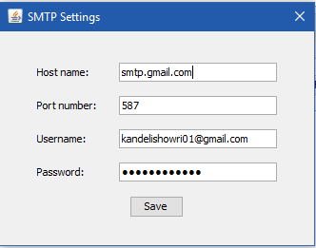

Figure 6: SMTP settings

Figure 5 shows the screenshot of the SMTP setting of the application. The SMTP setting for sending email includes a host name provided by mail service provider and port number along with username and password. The authentication is done using the information provided in above setting dialog.

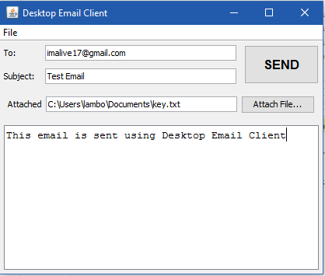

Figure 7: Sending Email

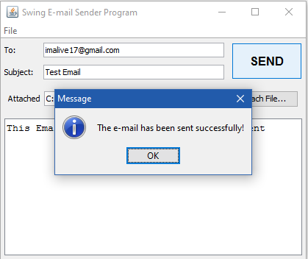

Figure 8: Mail Sent Successfully

The two figures above, Figure 6 and 7, show the sending of email using desktop email client.

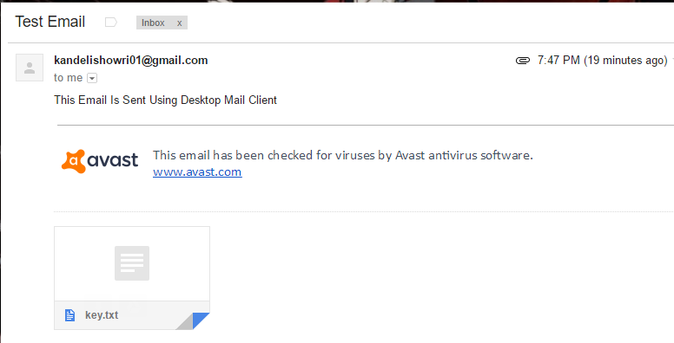

Figure 9: Email Received By Receiver

The figure 8 shows the email received by the receiving email address. Email was received along with the attachment.

## Critical Analysis

Development in communication technologies have emerged rapidly in last decade and among various communication technologies, e-mail also known as electronic mail have been used widely. E-mail creates reliable form of communication that is freely available and easily accessible [44]. Email is an asynchronous communication medium that connects people across large geographical region. The email communication is mostly limited to web based portal for normal users. Though there exist many desktop mail clients that can be used freely, there exist technical difficulty to operate such systems. Complex interface design and high level of functionality has limited those system mostly to technical personal only. Desktop email clients allows anyone to manage information exchange via email message without actually having to log in and out of the web based email providers. The ubiquity of email availability is one the strengths of the internet whose phenomenal growth and popularity are also due to the popularity of email. Email is fast, cheap and easy to distribute and is now as necessary as telephone and other communication media or ever more necessary. Email services have become more and more elaborate and powerful and continue to evolve. Messages are no longer limited to textual contents; they can include any type of multimedia contents.

After the thorough investigation and study of the mail clients, the author has come to realize that email clients are necessary part of communication exchange. The use of email clients may have lot of impact on communication technology of any organization. Based on the critical analysis of web mail and desktop mail clients, the following conclusion were drawn

* Email is a powerful communication medium which exist on each and every level of organization.
* In context of Nepal, very few of the users are using desktop mail clients.
* Mail clients are not just for viewing mail. They are also a strong security measure to protect personal information of the user.

For the development of the desktop mail client, java technology was chosen as a developing platform. The reason why java was chosen was because of cross platform compatibility and open source. Being an opens source platform java community provides various API’s for building mail clients. Support for PoP3 and IMAP protocols are also provided in such API’s. Among few mail protocols to choose from, IMAP and PoP3 protocol were chosen for desktop mail client.

The Post Office Protocol 3 is an internet standard mail access protocol which allow user to access the mailbox located in mail server. Like SMTP, PoP3 is a stateful protocol which consist of client side running on user computer as part of MUA and PoP3 server running on mail server. The PoP3 protocol was used because it allowed used to access their mailbox and also provides the user the option whether to keep the files on the server or delete from the mail server. The huge advantage of using PoP3 was its support of offline mode, that is, once the message have been stored in clients computer, there is no need of maintaining connection to mail server i.e. every mail can be accessed and manipulated from the client side. The IMAP protocol was designed to overcome the PoP3 limitations. IMAP supports off-line, on-line and disconnected models. With online mode of IMAP protocol user can access their mail form the mail server. The disconnected mode allows user to download message form mail server, manipulates them and then upload the change to synchronize the server mailbox so the mailbox is always constant.

After the choice of using Java technologies was made for the development of the system, the choice of which specific technology and framework was to be made. After researching about various possible technologies, a list of technologies that could have been used were:

* Java web application for email client
* Using swing technologies

Since the proposed system was to develop a desktop mail client, swing technology was used. Swing is a java programming component that can be used to develop a GUI interface for an application. Using java web technologies to develop a desktop application was discarded because the application runs on browser and may depends on which browser user is using. According to the browser the performance of the application may vary. Some of the disadvantages of using web based application are:

* Larger Overhead: The web based application are slower than the native desktop application.
* Online Script: Many web based application load script and stylesheet online. If the internet connection goes down the application may not work as expected.
* Browser compatibility: The performance of the application may depend which browser the user is using. Outdated browser may not support all the features of the application.

In contrary, Swing is a powerful technology which supports vast GUI development tools. Swing allows user to use native windows component like toolbar, panel, buttons etc. Advance Windows Toolkit (AWT) as well as native swing components can be used to develop the application. Since java is cross platform compatible, the application does not depend on any specific operating system to run. It eliminates the problem faced in web based application.

Choice of the platforms and technologies used for the development of the system were made after a thorough analysis of all possible technologies. The choice was made based on the feasibility and comparative efficiency in the scenario of the project’s implementation. Besides the development technologies, the importance of desktop mail clients over web based systems was thoroughly analyzed with critical evaluation. Mail clients is not about sending and receiving mail but is about saving time and also securing your personal data.

## Limitation of the System

Some functionalities provided by the web mail client are not present on the application. Some of the limitation of the system are:

* Desktop mail client lacks intelligent user interface and functionalities such as auto complete of email address while sending mail
* The UI design is primitive in contrast to modern mail clients
* Various categories such as important mail, trash, flagged mail are not available in the application
* Formatting email with font style and font size is not available

## Recommendation to the Organization

Guru Infosys has been developing both desktop and web based system using various technologies such as .NET and Java. The goal of the organization is to provide quality service to the customers and has been exceeding the client expectations. However, the development team is responsible for front end and backend. Since, front end and backend of the project is done by same team, the process can be time consuming. Another strong recommendation to the organizations is to use web based repository such as Github, so exchanging code between programmers is easier and developers can also work from home during strike or any unexpected holidays.

## Recommendation to the Internship Program

The university has put great effort to include various courses that would help in the real world working environment. The university must execute some research and studies to select the courses that fulfill the current market requirements that would help the students to qualify themselves in the practical implications as well. Some of the recommendation to internship program are:

* University should conduct various program with collaboration with university so student would get enough exposure before starting internship.
* A minimum guideline should be set which must be followed by organization for the internship programs
* Defining concrete area for the internship program is strongly recommended

# CHAPTER 6: CONCLUSION

With this internship program, the author has gained more insight into the professional environment in the IT industry. The whole period of internship at Guru Infosys is considered to be very productive in preparation for real world working experience. During the 3 month of internship program, the author got insight of how software is developed and deployed for clients. Some of the tools and technologies learnt during the internship program were java, postgres SQL, Ajax and JavaScripts.

The project on “**Implementing IMAP and PoP3 protocol for desktop mail client**” delivers an email client system which connects with user’s web mail server and extracts all the email form the server to the local computer. It is a Java swing based desktop application built to ease the process of email management for an individual or an organization.

The application can further be improved to overcome all the shortcomings of the current version. In this internship program the author developed a simple network application which can provide a better way of interaction with email. The internship offered author with the opportunity of working with senior colleagues under pressure. In short, the internship provided author with the experience of professional field and better understanding of development and implementation of system.

# REFERENCES

|  |  |
| --- | --- |
| [1] | J. Xie, "What is an internship," Looksharp, [Online]. Available: https://www.looksharp.com/guides/what-is-an-internship. [Accessed 15 December 2016]. |
| [2] | Chegg Service, "What is an Internship?," Chegg Service, [Online]. Available: http://www.internships.com/student/resources/basics/what-is-an-internship. [Accessed 12 December 2016]. |
| [3] | WikiJobs, "What is an Internship?," WikiJobs, [Online]. Available: https://www.wikijob.co.uk/content/internships/advice/what-internship. [Accessed 15 December 2016]. |
| [4] | Ruthclarke, "What is an Internship?," [Online]. Available: http://www.graduateadvantage.co.uk/blog/2011/09/what-is-an-internship/. [Accessed 15 December 2016]. |
| [5] | Christin, "What is An Email Client," MailBird, 08 January 2015. [Online]. Available: https://www.getmailbird.com/what-is-an-email-client/. [Accessed 19 December 2016]. |
| [6] | L. Koo, "C|net," 22 June 2012. [Online]. Available: https://www.cnet.com/forums/discussions/what-are-the-pros-and-cons-of-web-based-e-mail-systems-566232/. [Accessed 25 September 2016]. |
| [7] | A. Shields, "Must-know: An overview of the software industry," Market Realist, 01 July 2014. [Online]. Available: http://marketrealist.com/2014/07/must-know-overview-software-industry-2/. [Accessed 16 December 2016]. |
| [8] | Business Software Alliance, "Software Industry Fact and Figures," Business Software Alliance, [Online]. Available: http://www.bsa.org/country/public%20policy/~/media/files/policy/security/general/sw_factsfigures.ashx. [Accessed 16 December 2016]. |
| [9] | Investopedia, "The Industry Handbook: Software Industry," Investopedia, [Online]. Available: http://www.investopedia.com/articles/markets/050416/industry-handbook-software-industry.asp. [Accessed 16 December 2016]. |
| [10] | B. Grad, "Software Industry," ETHW, [Online]. Available: http://ethw.org/Software_Industry. [Accessed 16 December 2016]. |
| [11] | D. Nield, "Tech in our everyday life," [Online]. Available: http://techin.oureverydaylife.com/effects-email-communication-1250.html. [Accessed 26 Septemember 2016]. |
| [12] | X. Hu, *Developemnt of Textual Email Client in java,* University of Bath, 2005. |
| [13] | "The History of Email," [Online]. Available: http://emailhistory.org/. [Accessed 28 September 2016]. |
| [14] | "A Brief History Of Email," [Online]. Available: https://www.cs.umd.edu/class/spring2002/cmsc434-0101/MUIseum/applications/emailhistory.html. [Accessed 26 Septemeber 2016]. |
| [15] | T. V. Vleck, "The History of Electronic Mail," [Online]. Available: http://multicians.org/thvv/mail-history.html. [Accessed 28 September 2016]. |
| [16] | I. Peter, "Brief History of Email," [Online]. Available: http://www.nethistory.info/History%20of%20the%20Internet/email.html. [Accessed 28 September 2016]. |
| [17] | D. Crocker, "Email History," [Online]. Available: http://www.livinginternet.com/e/ei.htm. [Accessed 28 September 2016]. |
| [18] | M. Rouse, "IAMP (Internet Message Exchange Protocol)," [Online]. Available: http://searchexchange.techtarget.com/definition/IMAP. [Accessed 26 Septmember 2016]. |
| [19] | "The IAMP protocol," [Online]. Available: http://networking.ringofsaturn.com/Protocols/imap.php. [Accessed 26 Septmember 2016]. |
| [20] | C. L. H. a. J. D. M. C. E. Landwegr, "A security model for military message system: Retrospective," Naval Research Laboratory, 2001. [Online]. Available: http://www.chacs.nrl.navy.mil/publications/CHACS/2001/2001landwehr-ACSA.pdf. [Accessed 15 Novemember 2016]. |
| [21] | R. Oppliger, "Certified Mail: the next challenge for secure messaging," *Communications of ACM,* vol. 47, no. 8, pp. 75-79, 2004. |
| [22] | klensin, *Simple Mail Transfer Protocol,* 2001. |
| [23] | M. Jakobsson and S. Myers, Phishing and Countermeasures: Understanding the Increasing Problem of Electronic Identity Theft, Adobe E-Book, 2006. |
| [24] | T. Elgamel and K. Hipman, "Secure Socket Layer Application Program Apparatus and Method". Patent U.S. Patent No:5657390, 1997. |
| [25] | MindTools, "What is Time Management," Mind Tools, [Online]. Available: https://www.mindtools.com/pages/article/newHTE_00.htm. [Accessed 18 December 2016]. |
| [26] | TechTarget, "Cost Management," TechTarget, [Online]. Available: http://whatis.techtarget.com/definition/cost-management. [Accessed 18 December 2016]. |
| [27] | M. Rouse, "Project Management," TechTarget, August 2016. [Online]. Available: http://searchcio.techtarget.com/definition/project-management. [Accessed 18 December 2016]. |
| [28] | Association for Project Management, "Project Management Fundamentals," Association for Project Management, [Online]. Available: https://www.apm.org.uk/resources/what-is-project-management/. [Accessed 18 December 2016]. |
| [29] | Techopedia, "System Analysis," Techopedia, [Online]. Available: https://www.techopedia.com/definition/9611/systems-analysis. [Accessed 18 December 2016]. |
| [30] | Sreejith, "Feasibility Study - Software Engineering," 27 July 2009. [Online]. Available: http://softwarefeasibilitystudy.blogspot.com/2009/07/feasibility-study-software-engineering.html. [Accessed 18 December 2016]. |
| [31] | D. Hofstrand and M. H. Clause, "What is a Feasibility Study?," Iowa State University, October 2009. [Online]. Available: https://www.extension.iastate.edu/agdm/wholefarm/html/c5-65.html. [Accessed 18 December 2016]. |
| [32] | D. Thakur, "What is Feasibility Study? Types of Feasibility. Explain Feasibility Study Process," Computer Notes, [Online]. Available: http://ecomputernotes.com/software-engineering/feasibilitystudy. [Accessed 19 December 2016]. |
| [33] | Mukund, "Feasibility Study – An Important aspect of Project Management," Simplilearn, 15 July 2012. [Online]. Available: https://www.simplilearn.com/feasibility-study-article. [Accessed 19 December 2016]. |
| [34] | Reference, "What is Operational Feasibility?," Reference, [Online]. Available: https://www.reference.com/business-finance/operational-feasibility-300ab6b96428cf68. [Accessed 19 December 2016]. |
| [35] | Task Management Guide, "What is Schedule Feasibility," Task Management Guide, [Online]. Available: http://www.taskmanagementguide.com/glossary/what-is-schedule-feasibility.php. [Accessed 19 December 2016]. |
| [36] | Reference, "Context-Diagram," Reference, [Online]. Available: https://www.reference.com/technology/context-diagram-974c18ccb9ff70d. [Accessed 19 December 2016]. |
| [37] | Tutorial Points, "Software Analysis and Design Tools," Tutorial Points, [Online]. Available: https://www.tutorialspoint.com/software_engineering/software_analysis_design_tools.htm. [Accessed 20 December 2016]. |
| [38] | K. Fakhroutdinov, "UML Use Case Diagram," [Online]. Available: http://www.uml-diagrams.org/use-case-diagrams.html. [Accessed 20 December 2016]. |
| [39] | "A quick introduction to UML sequence diagrams," [Online]. Available: http://www.tracemodeler.comarticles/a_quick_introduction_to_uml_sequence_dia. [Accessed 20 December 2016]. |
| [40] | Tutorial Points, "Software Testing," Tutorial Points, [Online]. Available: https://www.tutorialspoint.com/software_testing/software_testing_overview.htm. [Accessed 19 December 2016]. |
| [41] | "Unit Testing," Software Testing Fundamentals, [Online]. Available: http://softwaretestingfundamentals.com/unit-testing/. [Accessed 19 December 2016]. |
| [42] | "Types of Software Testing," Software Testing Help, 14 December 2016. [Online]. Available: http://www.softwaretestinghelp.com/types-of-software-testing/. [Accessed 19 December 2016]. |
| [43] | M. Rouse, "Acceptance Testing," TechTaeger, [Online]. Available: http://searchsoftwarequality.techtarget.com/definition/integration-testing. [Accessed 19 December 2016]. |
| [44] | "Reference.com," [Online]. Available: https://www.reference.com/technology/email-important-deedd2f9f98bd674. [Accessed 25 September 2016]. |